A000-Afr-DR Congo-Headrest-Janus *musamo* or headrest of the Tabwa people-female-Early 20th c

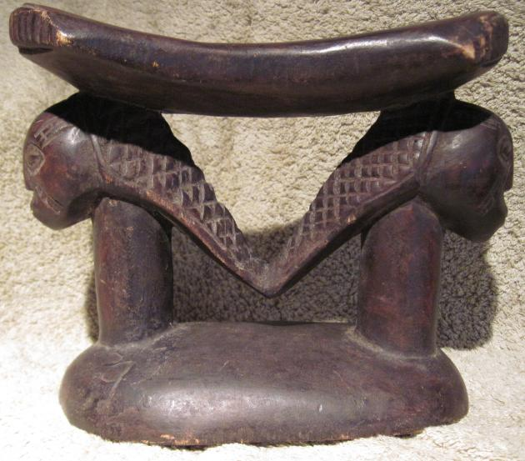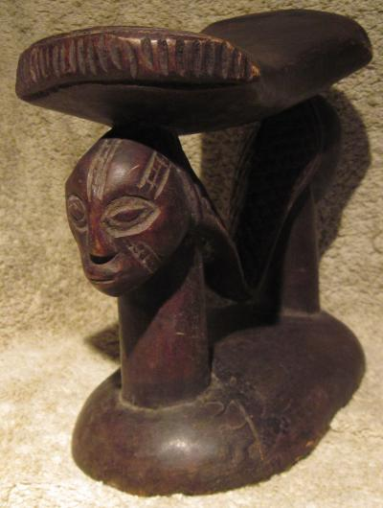

Figs. 1-2. Afr-DR Congo-Headrest-Janus *musamo* or headrest of the Tabwa people-female-Early 20th c

Case No.: 6

**Accession No.**

**Formal Label:** Afr-DR Congo-Headrest-Janus *musamo* or headrest of the Tabwa people-female-Early 20th c

**Display Description:**

This Janus-faced "Lusinga" headrest is an important divination object of the Tabwa, a Bantu-speaking ethnic group of the Democratic Republic of the Congo (formerly Zaire, 1971-1997). Its design reflects the iconographies of the three closely affiliated Bantu-speaking ethnic groups of east Central Africa: the Luba, the Tabwa and the Hemba. All three enjoyed participation in the *Bugabo,* a mutual-aid society. This headrest is also is intimately connected with the deadly clash between the Congolese Chief, Lusinga Iwa Ng'ombe, and the Belgian Lieutenant, Émile Storms, as they sought to establish their own separate African and European hegemonies, respectively, along the southwestern shores of Lake Tanganyika in the 1880s. Lusinga was notorious for his participation in the east African slave and ivory trade, while Storms was operating under a secret mandate from King Leopold of Belgium to emblazon "a White Line across the Dark Continent," to establish an Aryan zone partitioning Africa by the European colonial powers. In the inevitable confrontation that ensued, Lusinga was murdered and decapitated by Storms' African mercenaries. Storms absconded with Lusinga's skull, which became the subject of a sinister evolutionary treatise. Lusinga's ancestral figure was taken to Belgium where it is now ensconced in the Royal Museum of Central Africa, and this headrest, which is similar to those used by Lusinga and his supporters, stands as a mute testimony to the power that the inter-ethnic *Bugabo* society once had in this region.

**LC Classification:**

**Date or Time Horizon:**

**Geographical Area:**

**Map:**

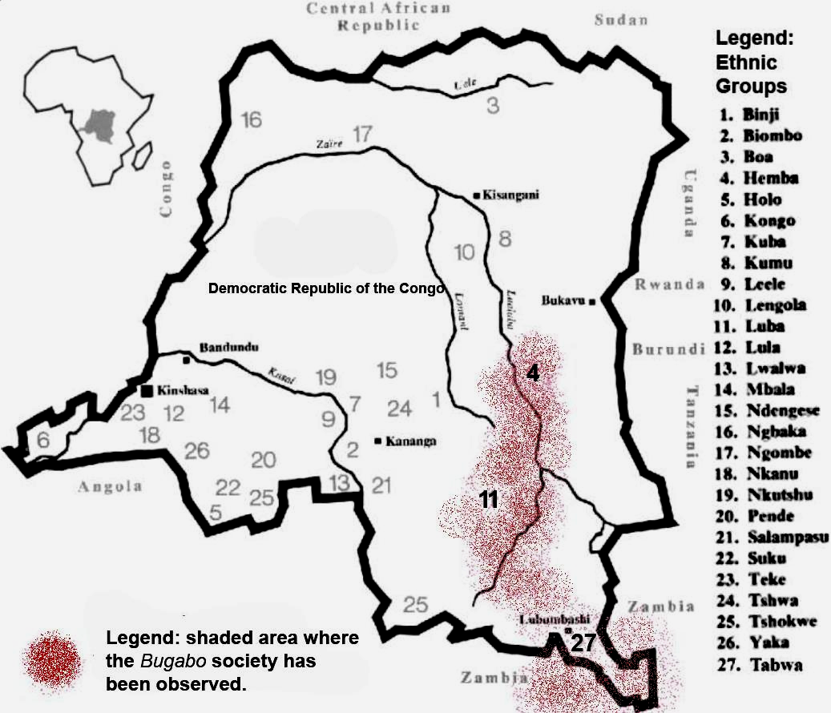

Fig. 3. Map of Zaire showing the locations of the Bantu-speaking Hemba (4) Luba (11) and Tabwa (27) ethnic groups who participated in the inter-ethnic Bugabo society.

**GPS coordinates:**

**Cultural Affiliation:**

**Media: wood, pigments**

**Dimensions:** 9" long, 7.5" high and 4" wide,

**Weight:**

**Condition:**

**Provenance:**

**Discussion:**

**References:**

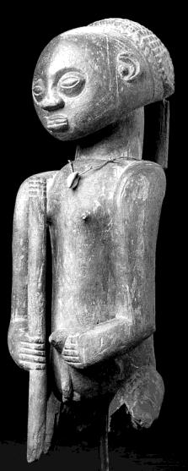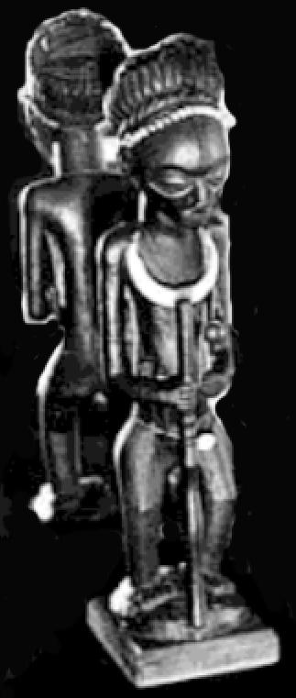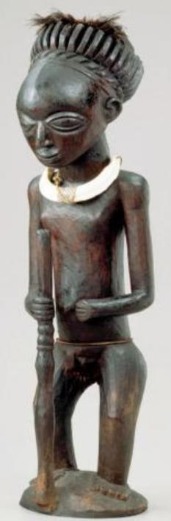

Fig. 4. "Lusinga" ancestral figure, 57 cm. high, wood fiber-cord, cowrie shell, collection of Richard and Jan Baum, Los Angeles after Roberts 2012, Fig. 8.1. Note the cowrie-shaped eyes and cowrie amulet necklace suggestive of the female vulva, the everted navel suggestive of a late stage of pregnancy, the facial keloids (scarifications) indicating tribal affiliation, and the coiffure that would have required a headrest to preserve its daily integrity with its cross-hatched design emulates the vocabulary of scarification patterns commonly found on Luba sculpture.

Fig. 5. Luba style standing figure of Chief Lusinga, who had it commissioned as a form of "statement art" to glorify his self-imposed claim to royalty. 68.6 cm. high. The figure in front of the mirror on the mantel of Storm's drawing room in Antwerp, Belgium, 1929, after a photo by G. Holz, Royal Museum of Central Africa, Tervuren, Belgium, from photograph HP. 1930.653.1 from Roberts 2012. Note its elaborate coiffure, a *mpiki* (*Cleistopholis patens*) seed necklace, a symbol of the Bugabo society.

Fig. 6. The same "Luisinga" figure as it appears in the Royal Museum for Central Africa today, acc. no. 31660, from Roberts 2012: cover. Note that its iconography is very similar to that of Fig. 4.

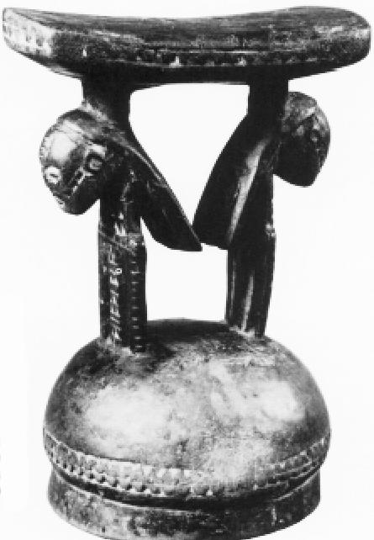 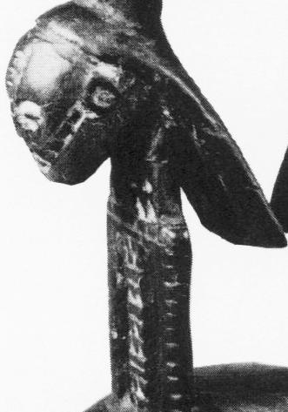

Fig. 6. Headrest, wood. 15.5 cm. Museum für Volkerkunde, Berlin , collected by Lt. Glauning, Marungu area, 1900. After Roberts 1986: 33, Fig. 11.

Fig. 7. Detail. This headrest shows the pendant coiffures and the keloid patterns on the face and body that were commonly practiced by nineteenth-century Tabwa men. Similar facial scarification patterns are on the headrest of Figs. 1 and 2, which suggests that they are also attributed to the Tabwa. After Roberts 1986: 33, Fig. 11.

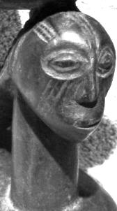

Fig. 8. Detail of the Janus-faced "Lusinga" headrest showing the intricate facial keloids. Compare with Fig. 7.

Since the headrest and the wooden Lusinga figures are associated with the Bugabo territorial cult, it is crucial to understand its origins and operation. First, however, it is necessary to define what is meant by a territorial cult: " a territorial cult is an institution of spirit veneration which relates to a land area, or territory, rather than to kinship or lineage groupings. Its main function is to ensure the moral and material well-being of the population of that land area, and it will be especially concerned with rain-making or the control of floods, with the fertility of the soil for agriculture or with the success of fishing or hunting.' Finally, although a territorial cult is concerned with the total community of a land area, it is normally controlled by a limited elite of priests and functionaries. In this way a territorial cult can be distinguished from ancestral or clan veneration on the one hand and from movements of widespread and uncontrolled spirit possession on the other" (Ranger 1973:582).

The Bugabo cult provided not only an alternative to social structures of kin, clan, lineage, and chieftainship (cf. Zangrie 1947-50: 66, 70-71) but also new structures of regional as well as local-level networks. Based on its regional capacity the Bugabo Society was seen as a challenge to Belgian colonial interests in east-central Africa, both political and religious (Douglas 1969).

While the Bugabo Society was a latter nineteenth century ritual complex (Colle 1913: 601), its origins probably derive from the "synthesizing tendencies" of southeastern Congo peoples who demonstrated their abilities to syncretize elements of disparate cults under a new cultic complex, a new creative bricolage to use Levi-Straus's term (Gossiaux 1990; Biebuyck 1981: 23; Levi-Strauss 1966).



The origin of the term "Bugabo" is an enigma. It may be derived from the Bantu Luba verb –aba, "to share divide, honor or recognize someone through giving a portion" of food or other goods (Van Avermaet and Mbuya 1954: 2). This verb is based upon the Proto-Bantu root *-gab, "to give," which is also related to *mu-gavo/*mu-gabo, "a person who dispenses spiritual power" (Werner 1978: 99). Bantu-speaking groups of the southern Lake Tanganyika region, have a modern reflex of the Proto-Bantu *mu-gavo/*mu-gabo which is mwao (plural: miao) meaning "the spirits associated with natural shrines who are believed to control the forces of weather and disease," which shifts the referent from persons to spirits. This transformation associates spirits with the natural shrines that are believed to control weather and disease (Werner 1978: 99). Furthermore, evidence of the regional expansion of this powerful conjunction of inter-ethnic territorial ideas can be seen in a dialectical shift of mwao becomes nyau, the society celebrated for its masked Nyau performances among Mang'anja, Chewa, and related groups of northern and central Malawi (see Aguilar 1996, Yoshida 1993; cf. Robert 1948 and Willis 1968, 1981). The cult diffused as well among the Lega and the Bembe ethnic goups who called their territorial cult the Bwami Society, which, in full, was "bwame bwa bugabo" (Gossiaux 2000: 45; Baeke 2009: 40).

Aba also has other connotations that expanded its meaning to include (with a tonal shift) "to feel great emotion for or want a great deal, to lust after" Van Avermaet and Mbuya 1954: 2, 254) and (from ngabo) to act as a shield, a protection (Schmidt 1912: 273). Therefore, the term Bugabo incorporates a cluster of related meanings that collectively indicate a passion of people to attend spirits of natural shrines and their gifted human overseers to solicit the protection the people from vicissitudes of weather and disease. This is a concept that provided a linkage between Bugabo as a regional and inter-ethnic territorial cult and the need for protection of the land against ecological degradation, one of the consequences of European colonial lust for African natural and human resources.

Understandably, the European colonial powers of the early twentieth century clearly saw the social and military threat of Bugabo to their African expansionist aspirations. Bugabo was deemed heretical, both politically and religiously. A Belgian apologist exclaimed Bugabo "undoubtedly signifies sharing or communism" (Colle 1913: 601). Similarly, Belgian Catholic Monsignor Roelens equated Bugabo with Protestant Freemasonry, the anti-Christ of the time (Roelens 1904: 292).

However, Bugabo and its cognate cults were not to be easily suppressed. Its rituals, invocations, songs, and dances, as well as several forms of carved wooden sculpture associated with important magical devices proliferated in east and east-central Africa. Protection of the people, of the land from depredations as was perceived as a result of European greed was symbolized by the female anthropomorphic figure of kabwelulu who gestures to her breasts that she is the protective mother of her offspring and of her secret traditions, a figure that found its place among the Luba and their associated ethnic groups (Vandergam 1930, Roberts and Roberts 1996: 205).Sometimes these figures were household amulets set in gourds or baskets, sometimes hollowed to contain a precious quartz crystal or other medicine bundle amulet with its own magical efficacy (Roberts and Roberts 1996: 239; Petridis 2008: 43-45).

Indeed, this magical efficacy was annually witnessed in the cycle of the seasons that was explicated in the Luba mythwhereby the lord of excess (Nkongolo Mwamba) is opposed by his son, the avatar of moderation, Mbidi Kiluwe; however, these two seemingly opposing forces exemplify aspects of the other's attributes in their separate beings. The world of the Bugabo is a complex intermixture of excesses and moderations providing the model for humans that the desirable course of action is one of degree and not one of absolutes. This dialectical drama proceeds in demonstrable ways throughout the year. As farmers, these people of the Bugabo realized the importance of both rain and sunlight. Among the Tabwa, the avatar of rain, Nfwimina, is an overarching serpent who exhales the rainbow after having let forth the rain and so transforms himself into his duality, his solar aspect that makes plants and grasses sprout into maturity. Then, when the season again becomes dry and hunting parties burn the bush to hunt the hidden game, Nfwimina is seen standing on his tail as a spiral of smoke as he drives game to the hunters. Then Nfwimina provides meat for the people, but, even as the meat is being cooked, clouds are building on the horizon and Nfwimina once more becomes his duality -- the rain avatar -- to recommence the cycle of seasons (see Roberts 1986:26). Thus, the Bugabo encompasses this mythic cycles, encompassing the vicissitudes of humans and nature.

The followers of Bugabo were also politically very independent. Their tribal groups of the east central African region did not necessarily succumb even to the rule of local chieftains so why should they succumb to the colonialist Europeans. As a result they were spiritually consolidated by Bugabo but politically fragmented because of their lack of consolidating chieftainships. This left the door open for "sanguinary potentates" an epithet coined in 1879 by the British explorer Joseph Thomson for one Lusinga Iwa Ng'ombe. Lusinga was ruthless in slaving and ivory hunting for the east African trade and was anxious to set himself up as the pan-African overlord of the politically fragmented Luba, Tabwa and Hemba (Roberts 2012: 1).

The Janus-faced headrest and the statuary exemplifying the dualities presented above are the essence of the Bugabo philosophy. In the headrest is the juxtaposition of opposing yet conjoined androgynous ancestral figures. In the statuary, too, this is exemplified. Lusinga Iwa Ng'ombe actually commissioned the statue in Figure 5 above to symbolize his self-proclaimed royal access to ancestral powers that would confirm and validate his pan-African authority just as earlier local chiefs had begun to legitimize their authority (Roberts 2012: 21). In figures 4 and 5 above, the figures' left hands placed over the womb and touching the everted umbilical cord represent the female aspect of the ancestral lineage, while the figures' right hands hold a spear representing the warrior ideal of the male aspect. This iconography of duality also provides a window into the gender duality of sinister and dexter, left and right, female and male. Apart from headrests, there were other Janus-faced objects of magico-religious import such as talismans and pyrographic calabash drinking vessels. Apparently, these objects also emphasized the dualities of androgynous ancestors, of divination, of insight, of making decisions. For instance, we know that Lusinga Iwa Ng'ombe regularly communed with his ancestral statue pictured above (Fig. 5) in his specially secreted shrine. Hence the figure took on his name as its epithet, the "Lusinga." Here he would meditate while drinking an intoxicating beer from a pyrographic calabash seared with the image of another Janus "Lusinga" figure, after which he would sleep with his head on a Janus headrest to induce divination in dreams (Roberts 2012: 48). The cranium of the ruler was also invested with special arcane properties, since it would have been conserved after death for special veneration, while his body would be buried with that of his predecessor. The conservation of crania of ancestors in ossuaries is a world-wide phenomenon and apparently was practiced here in east central Africa. Associated with the cult of ancestors and their abiding presence, conserved crania were considered as links with intelligence from the beyond that could be accessed shamanistically. The Janus-faced "Lusinga" headrest mirrors the duality of the "Lusinga" statues. They may signify that the two heads supporting the platform are crania placed upon poles for the veneration of the Bugabo sodality. If so, they visually represent the embodiment of the ancestral philosophy of duality. The head resting on this headrest is contiguous to the ancestral medium and reifies the believer's ties to the eternal. However, the fate of Lusinga Iwa Ng'ombe's cranium was not to enjoy this normal course of events for its cultic veneration.

Enter Walloon Belgian commander Lieutenant Émile Storms of the International African Association's "caravan." Ostensibly a scientific expedition, this "caravan" was a covert military expedition devised by Léopold II, the Belgian king, to march his troops west from Lubanda (now in western Tanzania) to join up with British colonialist Henry Morton Stanley, had proceeded from the Atlantic coast up the Congo River. At the British-Belgian joining of forces it was expected that they would emblazon a "White Line across a Dark Continent," a supreme act of confidence that Black Africa had been conquered by the White Races, preparatory to the 1885 Berlin Conference when the European powers would partition Africa amongst themselves.

Obviously Storms had to get rid of his chief rival in this area, Lusinga Iwa Ng'ombe. So he sent mercenary African warriors to Lusinga's palisaded enclave in Lubanda, where they lulled Lusinga into oblivion with tribal dancing. On cue they murdered him by gunshot and beheaded him. Storms absconded with not only Lusinga's figure but also his decapitated cranium to his residence in Belgium. The Bugabo leader's power was seemingly destroyed, his ancestral line was seemingly shattered. Storm placed Lusinga's figure in front of a mirror on his drawing room mantle as an African military trophy. He presented Lusinga's skull to the physical anthropologist Émile Houzé, for verification of Belgian Walloon supremacy. Houzé dutifully analyzed the cranium and with conviction pronounced that it represented the degenerate features of the Flemish people as opposed to the Aryan features of the Walloons (Houzé 1882; Denoël 1992: 380). Back in Africa, the Bugabo society regarded the cranium as a familial and clan-based aspect of cultic ancestral memory (cf. Kristeva and Gladding 2011:14). And so today the cranium resides with the Belgian Museum of Central Africa.

Finally, it is unknown whether this Janus "Lusinga" headrest was used by Lusinga Iwa Ng'ombe 's followers or their antecedents, but it surely is a unique testimony to a unique nineteenth-century clash of European and African powers.

References:

Aguilar, Laurel Birch de. 1996. *Inscribing the Mask: Interpretation of Nyau Masks and Ritual Performances Among the Chewa of Central Malawi*. Freiburg: Studia Instituti Anthropos.

Anon. 1883. *The Congo: the white line across a dark continent with map. The operations of the Association Internationale Africaine and of the Comité dÉtude du Haut Congo from December 1877 to October 1882, by a participant in the enterprise*. London: E. and F. N. Spon.

Biebuyck, Daniel. 1981. "Buhabo Statues from the Benambaho (Bahoma)," *Africa-Tervuren* 1, 18-30.

Colle, Pierre. 1913. *Les Baluba*.. Anvers, Belgium: Albert Dewit. 2 vols

Denoël, T., ed. 1992. *Le nouveau dictionnaire des Belges*. Brussels: Le Cri.

Douglas, Mary. 1969. Techniques of Sorcery Control in Central Africa. In J. Middleton and E. Winter, eds., Witchcraft and Sorcery in East Africa,. London: Routledge and Kegan Paul, pp. 123-141.

Gossiaux, Pol Pierre. 1990. Les Maitres de Buli: Esthetique et Ethno-histoire (avec deux inedits), *Art et exotisme, Revue des historiens de l'art, des archiologues, des musicologues, et des orientalistes de l'Universiti de Liege 9, 38-49*. Also available at [µwww.anthroposys.be/buli/htm.](http://www.anthroposys.be/buli/htm.)§

Houzé, Émile. 1882*. Les indices céphaliques des Flamands et des Wallons*. Brussels: G. Mayolez.

Kristeva, Julia, and Gladding, Jody. 2011. The severed head: capital visions. New York: Columbia University Press

Levi-Strauss, Claude. 1966. *The Savage Mind*. Chicago: University of Chicago Press.

Petridis, Constantine. 2008. *Art* *and Power in the Central African Savanna.* Brussels: Mercatorfonds for the Cleveland Museum of Art.

.

Roberts, Allen F. 2012. *A Dance of Assassins: Performing Early Colonial Hegemony in the Congo*. Bloomington: Indiana University Press.

Roberts, Allen F. 1986. Duality in Tabwa art, *African Arts*, 19 (4): 26-35+86-87.

Roberts, Mary Nooter, and Allen Roberts. 1996. Memory: Luba Art and the Making of History. Munich: Prestel for the Museum for African Art, New York.

Roelens, Victor. 1904. Rapport sur la Mission du Haut-Congo, 1903- 1904, *Missions d'Afrique des Peres Blancs*, pp. 289-309.

Schoffeleers, Matthew, editor. 1978. Guardians of the Land: Essays on Central African Territorial Cults. Gwelo (Rhodesia, now Zimbabwe): Mambo Press.

Van Avermaet, E., and B. Mbuya. 1954. Dictionnaire kiluba-ranfais. *Annales du Musie Royal du Congo Belge, Sciences de l'Homme, Linguistique 7.* Tervuren, Belgium: Musée Royal du Congo Belge.

Zangrie, Luc. 1947-1950. Les institutions, la religion et lGart des Babuye (groupes Basumba, Manyeme, Congo Belge), *Ethnographie* NS 45, 54-80.

